THEORETICAL BIOLOGY · MATHEMATICAL MODELING
The Glycolytic Regeneration Pendulum
Basal Glycolytic Regime, Cytolytic Remodeling,
and Nonlinear Oscillatory Tissue Dynamics
Revised & Extended Edition · May 2026
Conceptual Preprint · Framework Article

Abstract
This work proposes a unified mathematical and conceptual framework in which tissue regeneration is interpreted as a nonlinear oscillatory process emerging from transitions between metabolic and structural states of tissue.
Unlike classical regeneration models centered primarily on vascular oxygen supply, the present framework emphasizes the dominant role of glycolytic metabolism during proliferation and repair. We introduce the concept of the Basal Glycolytic Regime (BGR) — a metabolic state characterized by increased reliance on glycolysis, elevated intracellular water content, reduced structural maturity, and enhanced proliferative potential.
Within this framework, regeneration is not driven primarily by apoptosis-based turnover, but by cyclic transitions between proliferative glycolytic states and cytolytic remodeling states. Young, embryonic-like, regenerating, and malignant cells are proposed to exist in a metastable high-water state that is mechanically vulnerable to energetic perturbation. Under conditions of local instability, these cells preferentially undergo cytolytic destruction rather than classical apoptosis, producing abrupt release of matrix metalloproteinases (MMPs), inflammatory mediators, and damage-associated molecular patterns (DAMPs).
This generates a nonlinear feedback loop:
proliferation → glycolytic instability → cytolysis → MMP burst → vascular remodeling → increased substrate delivery → renewed proliferation
The resulting system behaves as a relaxation-type oscillator. We correct three structural inconsistencies of prior formulations and incorporate the BGR mechanism throughout: (1) N(t) is decoupled from E(t) via an explicit relaxation equation; (2) remodeling is driven by actual cellular glycolytic energy deficit, not by distance from the vascular ceiling; (3) the defect variable D(t) is bidirectionally coupled to energy dynamics, so that defect closure genuinely modulates system behavior.
The framework integrates glycolytic metabolism, vascular adaptation, hydrogel-like cellular mechanics, and regenerative oscillations into a unified model with explicit mathematical structure, three observable dynamical regimes, and testable experimental predictions.

1. Introduction — Tissue as a Metabolic Oscillatory System
The healing of damaged tissue is a cyclical process whose temporal structure has not been fully captured by existing mathematical models. Classical approaches treat proliferation as a direct function of growth-factor concentration or mechanical strain, but often neglect two fundamental constraints: the energetic architecture imposed by the vasculature, and the metabolic regime in which proliferating cells actually operate.
Living tissue is traditionally described through molecular signaling pathways, stem-cell hierarchies, and growth-factor networks. These descriptions tend to treat metabolism as secondary to regulation. In contrast, the present framework proposes that:
tissue dynamics are fundamentally constrained and organized by metabolic state transitions.
We propose that tissue exists as an oscillatory metabolic system composed of two interacting components: (1) basal maintenance metabolism, and (2) regenerative oscillatory metabolism. These components continuously interact through substrate consumption, structural instability, and vascular adaptation.
The central hypothesis of this work is that regeneration represents amplification of a continuously operating glycolytic oscillatory process, and that the primary driver of remodeling oscillations is not apoptosis but cytolysis — the abrupt, explosive membrane rupture of high-water-content proliferative cells under energetic overload.
We propose that tissue regeneration is best understood as a constrained nonlinear oscillator. The growth of a population of new cells increases metabolic demand, producing a transient energy deficit. Cells unable to meet this deficit undergo cytolytic destruction, releasing a burst of matrix metalloproteinases (MMPs) that promote vascular remodeling and increased perfusion. This completes one cycle of the pendulum:
growth → glycolytic energy deficit → cytolysis → MMP-driven vascular remodeling → increased substrate delivery → renewed growth
When the tissue defect closes, the oscillation is extinguished and the system returns to baseline. When the defect persists — as in benign neoplasia — the system approaches the energetic ceiling and stabilizes there. These two outcomes define the two principal dynamical regimes of the model.

2. Basal Glycolytic Regime (BGR)

2.1 Definition
We introduce the concept of the Basal Glycolytic Regime (BGR). BGR describes a metabolic state in which cells preferentially utilize glycolysis despite adequate oxygen availability. This phenomenon is well recognized in proliferating cells and is related to, but distinct from, the pathological Warburg effect of malignant tissue.
BGR is characteristic of:
- embryonic and fetal tissue
- stem-cell niches and transit-amplifying compartments
- blastema formation in regenerating amphibians
- wound-edge tissue in early repair
- proliferative compartments of adult renewing tissues
- malignant tissue

2.2 Structural Features of BGR Cells
Cells operating in BGR exhibit a characteristic phenotype that distinguishes them from mature differentiated cells:
- increased intracellular water content
- reduced cytoskeletal maturity and structural rigidity
- elevated proliferative capacity and mitotic index
- reduced oxidative phosphorylation dependence
- increased metabolic plasticity and substrate flexibility
These features resemble immature or partially dedifferentiated cellular states, consistent with the ontogenetic framework in which BGR cells occupy states closer to S₋₁ than to the terminal differentiated state S₀.

2.3 The High-Water Cellular State
A central assumption of the model is that proliferative glycolytic cells exist in a metastable high-water phase. This state behaves mechanically similarly to a weakly stabilized hydrogel system. Compared with mature differentiated cells, BGR cells possess:
- lower structural rigidity and higher osmotic sensitivity
- greater susceptibility to abrupt membrane failure under osmotic stress
- reduced ability to sustain sustained energy deficit without structural collapse
This mechanical vulnerability is not incidental but functional: it ensures that energetically overloaded cells are rapidly cleared, releasing remodeling signals that drive the next phase of the regenerative cycle.

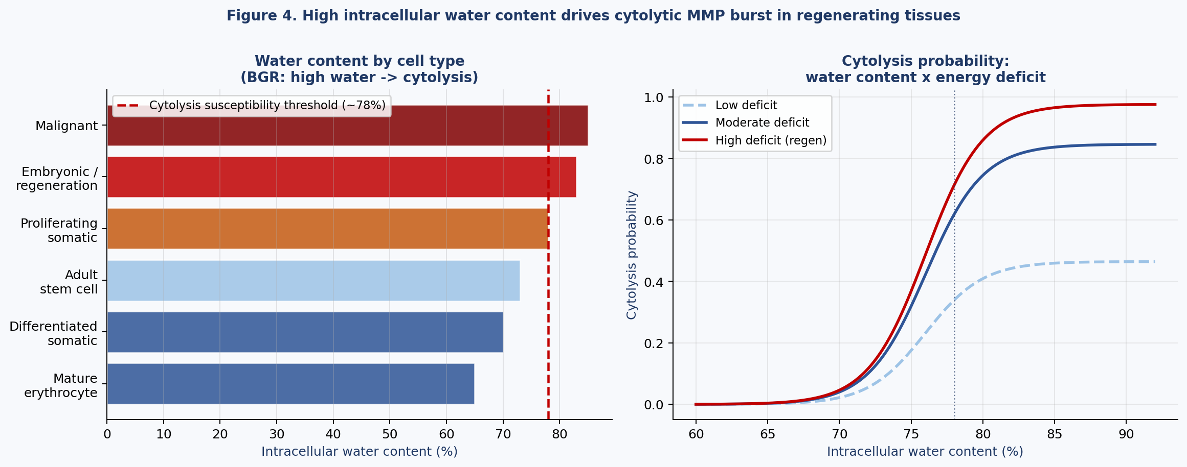
Figure 1. Intracellular water content by cell type and cytolysis probability. Left: BGR cells (embryonic, regenerating, malignant) have water content exceeding the cytolysis susceptibility threshold (~78%). Right: cytolysis probability as a joint function of water content and energy deficit.

3. Dual Energetic System of Tissue

3.1 Two Metabolic Components
The original regeneration pendulum model treated vascular oxygen delivery as the primary and sole energetic constraint on tissue growth. In the present framework, tissue energy supply is divided into two coupled systems:
E_tot = E_gly + E_ox
where E_gly is glycolytic energy production and E_ox is oxidative phosphorylation-dependent energy production. These two components have different kinetics, different substrate dependencies, and different ceiling constraints.

3.2 Oxidative Constraint
Oxidative energy remains constrained by vascular transport capacity following Hagen–Poiseuille-type scaling:
E_ox ≤ λ R⁴
where R is the effective vessel radius and λ encodes fluid viscosity, pressure gradient, and metabolic conversion efficiency. This introduces a hard geometric ceiling on oxidative energy supply that cannot be overcome by cellular adaptation alone.

3.3 Glycolytic Constraint
Critically, proliferative tissue operating in BGR may transiently bypass oxidative limitation through glycolytic metabolism:
E_gly ≤ G_lim
where G_lim represents substrate availability: local glucose concentration, lactate recycling, glycogen reserves, and diffusion limits from the interstitium. Thus, vascular oxygen delivery is no longer the sole energetic ceiling of regeneration. The effective energy ceiling is the minimum of both constraints:
E_lim^eff = min(λ R⁴, G_lim)
This dual constraint structure is a key revision of the original model. During active BGR, G_lim may become the binding constraint even when vascular supply is adequate, explaining why highly proliferative tissue can be simultaneously well-perfused and energetically overloaded.

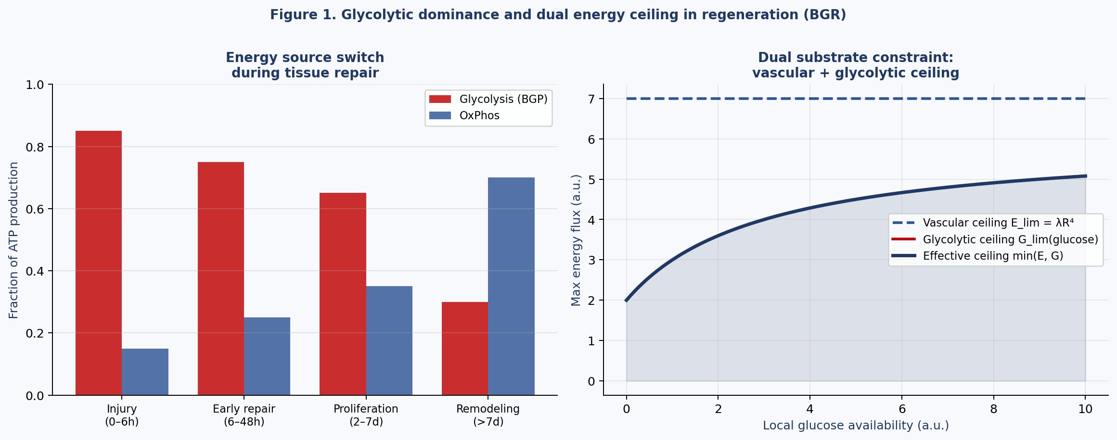
Figure 2. Glycolytic dominance during tissue repair and dual energy ceiling. Left: fraction of ATP production from glycolysis versus oxidative phosphorylation across repair phases. Right: effective energy ceiling as the minimum of vascular (E_ox) and glycolytic (E_gly) constraints.

4. Mathematical Model

4.1 State Variables

Variable | Description | Units
N(t) | Number of actively proliferating cells | cells
E(t) | Incoming metabolic energy flux (total) | J s⁻¹
E_gly(t) | Glycolytic energy flux component | J s⁻¹
E_ox(t) | Oxidative energy flux component | J s⁻¹
M(t) | Remodeling activity level (MMP proxy) | a.u.
D(t) | Residual defect size | cells or mm²
W(t) | Mean intracellular water content of proliferating population | fraction

4.2 Energy–Cell Coupling (Revised)
We retain the explicit relaxation equation from the corrected pendulum model, now incorporating the BGR dual-energy structure:
dN/dt = (1/τ_N)·[E_tot(t)/q − N(t)] − δ_cyt·Φ(W, qN−E_tot)·N
where τ_N is a proliferation timescale, q is the energy cost per cell, and the cytolytic loss term δ_cyt·Φ(⋅) replaces the simple apoptosis term δ·Θ(qN−E) of the original model. The function Φ encodes the joint dependence of cytolytic probability on water content W and energy deficit:
Φ(W, ΔE) = σ(W − W_c) · (1 − exp(−ΔE / ε))
where σ(⋅) is the logistic function with threshold W_c ≈ 0.78 (the cytolysis susceptibility threshold), and ε is a characteristic energy deficit scale. This function is zero when cells are well-supplied (no deficit) and also zero for low-water mature cells regardless of deficit, ensuring that cytolysis is specific to the BGR population.

4.3 Glycolytic and Oxidative Energy Dynamics
The two energy components are governed by separate dynamics:
dE_gly/dt = r_g·S(t)·N(t) − d_g·E_gly(t), E_gly(t) ≤ G_lim
dE_ox/dt = c·M(t) − d·E_ox(t), E_ox(t) ≤ λ R⁴
E_tot(t) = E_gly(t) + E_ox(t)
where r_g is the glycolytic rate coefficient, S(t) is local substrate (glucose) availability, and the oxidative component retains the original MMP-driven vascular remodeling structure. This formulation allows E_gly to be substrate-limited independently of vascular remodeling.

4.4 Remodeling Dynamics (Revised)
The remodeling equation is corrected to be driven by actual cellular energy deficit rather than distance from the vascular ceiling, and extended to reflect the burst character of cytolytic MMP release:
dM/dt = a·max(qN(t)−E_tot(t), 0)·[1 + β·Φ(W, qN−E_tot)] − b·M(t)
The term β·Φ(⋅) is the BGR correction: it amplifies MMP release specifically in BGR cells undergoing cytolysis, producing the burst dynamics that drive oscillatory behavior. When β = 0 the equation reduces to the apoptotic model; the cytolytic regime requires β > 0.

4.5 Water Content Dynamics
We introduce a minimal equation for the mean water content of the proliferating population:
dW/dt = α_W·(W_BGR − W)·ρ_gly − γ_W·(W − W_mat)·ρ_ox
where W_BGR is the high-water BGR setpoint, W_mat is the mature differentiated cell water content, ρ_gly = E_gly/E_tot is the glycolytic fraction, and ρ_ox = E_ox/E_tot is the oxidative fraction. As the glycolytic fraction dominates (BGR), W is pulled toward W_BGR; as oxidative metabolism takes over (remodeling complete), W declines toward W_mat.

4.6 Defect Closure — Bidirectional Coupling
The defect variable retains bidirectional coupling to energy dynamics:
dD/dt = −h·N(t)
E_lim^eff(t) = λ R⁴ · f(D), f(D) = D / (D₀ + D)
As D → 0, the angiogenic stimulus diminishes and the system returns to baseline. The glycolytic ceiling G_lim is not modulated by D, reflecting the substrate-independence of glycolytic energy from vascular structure.

5. Sources of Nonlinearity

# | Mechanism | Mathematical Form | Effect
NL-1 | Oxidative flux saturation | E_ox ← min(E_ox, λR⁴) | Hard vascular ceiling; piecewise dynamics
NL-2 | Glycolytic flux saturation | E_gly ← min(E_gly, G_lim) | Substrate ceiling; independent of vasculature
NL-3 | Cytolysis threshold | Φ(W, ΔE) = σ(W−W_c)·(1−e^(−ΔE/ε)) | Burst MMP release specific to BGR cells
NL-4 | Deficit-driven remodeling | max(qN−E_tot, 0) | Unidirectional forcing; vanishes in surplus
NL-5 | Defect–energy coupling | f(D) = D/(D₀+D) | Closure modulates oxidative ceiling
NL-6 | Water content oscillation | W coupled to ρ_gly / ρ_ox ratio | BGR fraction tracks metabolic phase

6. Cytolytic Remodeling

6.1 From Apoptosis to Cytolysis
Classical regeneration models emphasize apoptosis as the primary mechanism of cellular turnover. The present framework proposes that highly glycolytic immature cells preferentially undergo cytolytic destruction rather than controlled apoptotic elimination. This distinction is not merely semantic: the two modes of cell death produce fundamentally different downstream signals and operate on different timescales.

6.2 Cytolysis as a Physical Transition
Due to high intracellular water content and reduced structural stability, energetic collapse in BGR cells may trigger a cascade of physical events:
- osmotic destabilization driven by failure to maintain ion pump activity
- membrane rupture following hydrostatic pressure buildup
- hydrogel-like structural collapse releasing intracellular contents
This process is rapid, nonlinear, and threshold-dependent, consistent with the Φ(W, ΔE) formulation introduced in Section 4.2.

6.3 Consequences of Cytolysis: MMP Burst
Cytolysis produces abrupt, explosive release of:
- matrix metalloproteinases (MMPs) — primary drivers of extracellular matrix remodeling
- extracellular ATP — purinergic signaling and vascular activation
- HMGB1 and other DAMPs — inflammatory activation
- cytokines and intracellular enzymes
Unlike apoptosis, this release is a burst rather than a gradual process. The β·Φ(⋅) term in the remodeling equation (Section 4.4) captures this burst character, ensuring that MMP activity M(t) exhibits sharp peaks rather than smooth responses to deficit.

6.4 Positive Feedback and Oscillatory Drive
The cytolytic mechanism introduces intrinsic positive feedback into the system:
cytolysis → inflammation → vascular activation → glycolytic proliferation → cytolysis
This feedback loop naturally generates oscillatory behavior of a relaxation type: slow build-up during the glycolytic expansion phase, rapid discharge during the cytolytic remodeling phase.

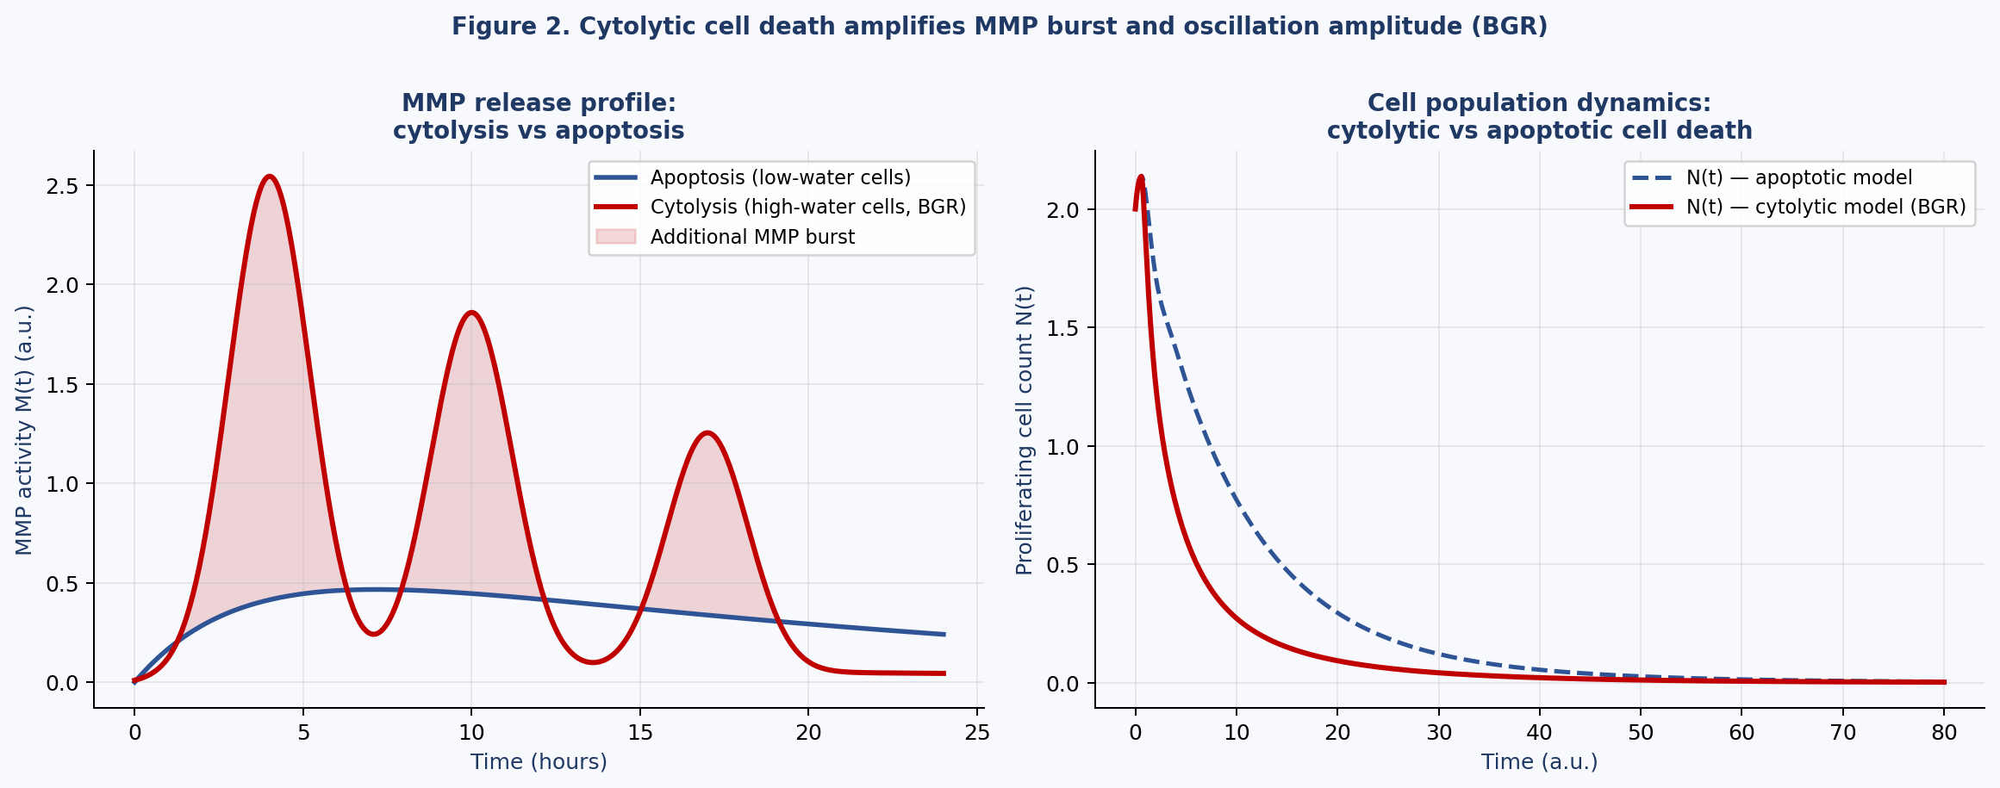
Figure 3. Cytolytic versus apoptotic MMP dynamics. Left: MMP release profile showing burst character of cytolysis compared with gradual apoptotic release. Right: N(t) simulation comparing cytolytic model (BGR) with apoptotic model, demonstrating enhanced oscillation amplitude under cytolysis.

7. The Cytolytic Oscillator of Regeneration

7.1 Regeneration as a Relaxation Oscillator
The regenerative cycle under BGR consists of two alternating phases:

Phase I — Glycolytic Expansion
- high proliferation driven by BGR metabolism
- increasing intracellular water content (W → W_BGR)
- substrate accumulation and glycolytic overload
- growing energy deficit as N approaches E_tot/q
- structural instability of the BGR cell population

Phase II — Cytolytic Remodeling
- threshold crossing: Φ(W, ΔE) becomes significant
- burst membrane rupture and MMP release
- inflammatory activation and vascular remodeling
- increased substrate delivery; W declines toward W_mat
- renewed proliferative capacity for the next cycle

7.2 Mitotic Index as Metabolic Indicator
The mitotic index MI(t) is defined as the fraction of proliferating cells in mitosis at time t:
MI(t) = N_m(t) / N(t)
Within the BGR framework, the mitotic index reflects not only proliferation kinetics but also metabolic state. We propose:
MI(t) ∝ E_gly(t) / E_tot(t) = ρ_gly(t)
Thus the glycolytic fraction ρ_gly serves as the metabolic driver of proliferative intensity. Regenerative amplitude A is interpreted as:
A ∝ max(MI(t)) over one oscillatory cycle

7.3 Reduced System and Stability Analysis
Neglecting glycolytic saturation and fixing D = D∞ > 0 and W = W_BGR (full BGR regime), the system reduces to a two-dimensional flow in (E_ox, M) with the same Jacobian structure as the original pendulum:
J = (−d c ; −a(1+βΦ) −b)
The characteristic equation becomes:
μ² + (b+d)μ + [bd + ac(1+βΦ)] = 0
The oscillatory (focus) regime now requires:
(b − d)² < 4ac(1 + βΦ)
The BGR correction term βΦ > 0 widens the oscillatory regime relative to the apoptotic model: cytolytic amplification of MMP release makes oscillations easier to sustain, consistent with the biological observation that highly proliferative regenerating tissues exhibit vigorous oscillatory dynamics.

8. Dynamical Regimes

Regime I — Regeneration (Damped Oscillation)
When the defect closes (D → 0), f(D) → 0 reduces the effective oxidative energy ceiling and the angiogenic stimulus. Simultaneously, W declines toward W_mat as the oxidative fraction increases. The cytolytic term Φ diminishes, MMP burst amplitude decreases, and the oscillation is self-extinguishing. The system returns to baseline homeostasis.

Regime II — Benign Growth (Saturation Plateau)
When the defect persists (D > 0), the system approaches E_tot → E_lim^eff, N → E_lim^eff/q, M → M*. Cell density stabilizes at a finite plateau determined by vascular geometry and substrate availability. The BGR fraction stabilizes at an intermediate value. A benign tumor is defined as a system that has reached the effective energetic limit while preserving both constraint structures (vascular and glycolytic).

Regime III — Failed Regeneration (Persistent Oscillation)
For intermediate parameter regimes, particularly when the cytolytic amplification βΦ is high but the defect closure rate h is low, the system exhibits sustained oscillations without convergence. This corresponds to chronic wounds or recurrent inflammatory cycles. This regime is absent from the original apoptotic formulation and emerges naturally from the BGR-cytolytic correction.

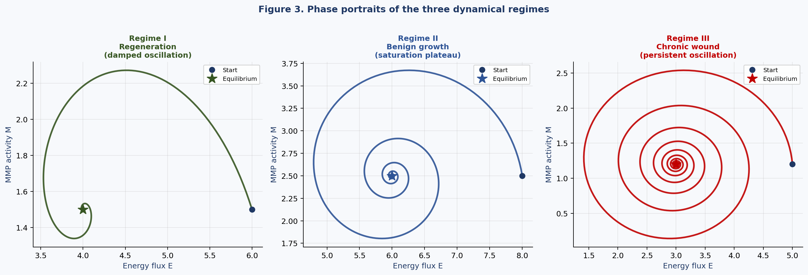
Figure 4. Phase portraits of the three dynamical regimes in the (E, M) plane. Regime I: damped oscillatory convergence to homeostasis. Regime II: saturation plateau at the energetic ceiling. Regime III: persistent oscillation corresponding to chronic wound-like states.

9. Distinguishing Benign from Malignant Growth

Property | Benign (Regime II) | Malignant
Constraint preservation | Yes — both E_ox ≤ λR⁴ and E_gly ≤ G_lim maintained | No — both violated via neoangiogenesis and substrate hijacking
BGR fraction ρ_gly | Stable intermediate value | Persistently maximal; does not decline with maturation
Water content W | Stabilizes at intermediate value | Persistently near W_BGR; structural immaturity maintained
Cell density | Stabilizes at plateau | Exponential or super-linear growth
Perfusion | Stable, normalized | Chaotic, heterogeneous (Jain 2005)
MMP activity | Declines to M* at equilibrium | Persistently elevated; drives invasion
Defect coupling | f(D) modulates E_lim^eff | Autonomous angiogenic signal replaces f(D)

Malignant growth corresponds to dual constraint violation: the tumor bypasses E_ox by secreting autonomous angiogenic factors (VEGF, FGF) independently of the defect signal, and bypasses G_lim through metabolic reprogramming that constitutively activates glycolytic enzymes. Mathematically, this is equivalent to replacing both f(D) with an autonomous term and removing the G_lim ceiling, breaking both stabilizing feedback loops simultaneously.

10. Testable Predictions

P1 — Scaling Law (R⁴)
Maximal benign tumor cell count should scale as the fourth power of the dominant feeding vessel radius, modulated by local substrate availability:
N_max = min(λ R⁴, G_lim) / q
A 10% increase in R predicts a ~46% increase in N_max at constant G_lim. Testable via histological morphometry combined with stereological cell counting.

P2 — Glycolytic Phase Leads Oscillation
In the BGR model, the glycolytic expansion phase precedes the MMP burst by a predictable interval. Specifically:
T_lag = τ_N · ln(W_BGR / W_c)
The lag between peak mitotic index and peak MMP activity should be measurable by multiphoton intravital imaging combined with metabolic reporters.

P3 — Oscillatory Signatures in Early Repair
Transient oscillations in tissue perfusion, MMP activity, lactate output, and metabolic flux should be observable during active regeneration, with characteristic period:
T ≈ 2π / √[ac(1+βΦ) − (b−d)²/4]
The BGR correction term βΦ increases the oscillation frequency relative to the apoptotic model. Detectable by dynamic contrast-enhanced MRI, diffusion-weighted MRI, or multiphoton intravital imaging.

P4 — Water Content Tracks Regenerative Phase
Diffusion-weighted MRI (DW-MRI) apparent diffusion coefficient (ADC) inversely correlates with intracellular water content. The model predicts that ADC should oscillate in phase with the BGR cycle, peaking during the cytolytic remodeling phase (low W) and reaching a minimum during glycolytic expansion (high W).

P5 — Cytolytic Signatures Precede MMP Peaks
Extracellular ATP, HMGB1, and cytokine bursts should precede MMP activity peaks by a short interval, reflecting the sequence: cytolysis → DAMP release → MMP induction. This temporal sequence distinguishes the BGR-cytolytic model from apoptotic models, where no such burst precursor exists.

P6 — Saturation Plateau in Benign Tumors
Benign tumors should exhibit stable, spatially uniform perfusion and an absence of exponential volume growth. Plateau cell density should correlate with the minimum of feeding vessel caliber and local glucose availability across tumor types.


Figure 5. Predicted glycolytic dominance pattern and dual constraint structure (reproduced from Section 3 for reference). These patterns are directly testable by 18F-FDG PET (glycolytic rate), DW-MRI (water content), and lactate spectroscopy.

11. The Energy Window
Stable tissue exists within a bounded energetic window:
(1 − ε)·E_tot(t) ≤ qN(t) ≤ E_lim^eff
Below the lower bound, cytolytic loss dominates and tissue mass declines. Above E_lim^eff, growth is physically impossible under either constraint. The width ε of this window is governed by kinetic parameters τ_N, δ_cyt, and the cytolytic threshold W_c, and determines how readily the system transitions between regimes under perturbation.
The BGR correction narrows the lower bound: because BGR cells are more susceptible to cytolysis at a given energy deficit, the effective tolerance band is compressed relative to the apoptotic model. This makes BGR tissue both more dynamically responsive and more prone to oscillatory instability — a feature that may be functionally important in rapid wound healing but pathological in chronic inflammation.

12. Experimental Implications

12.1 Predicted Observations in Regenerating Tissue
The framework predicts that active regenerative regions should exhibit, in temporal sequence:
- Elevated glycolytic flux (18F-FDG PET, lactate measurements) preceding MMP surge
- Increased intracellular water content (DW-MRI, ADC maps) during proliferative phase
- Abrupt extracellular ATP and HMGB1 elevation at phase transition
- MMP burst (zymography, in vivo imaging) following cytolytic peak
- Oscillatory tissue perfusion (Doppler, DCE-MRI) with period predicted by T formula
- Ki-67 index positively correlated with 18F-FDG uptake across the regenerative cycle

12.2 Imaging Predictions
The model predicts specific correlations between imaging biomarkers:
- 18F-FDG PET uptake and Ki-67 index should be in phase
- DW-MRI ADC and 18F-FDG should be anti-correlated (high water → high glycolysis)
- DCE-MRI perfusion should lag Ki-67 by approximately T_lag
- Lactate spectroscopy should parallel glycolytic flux

12.3 Distinction from Malignant Tissue
The temporal dynamics distinguish BGR-regeneration from malignant BGR: in regeneration, W and ρ_gly decline after the cytolytic phase as the tissue matures. In malignant tissue, W and ρ_gly remain persistently elevated across multiple cycles. Serial DW-MRI and metabolic imaging could therefore provide a non-invasive kinetic signature distinguishing physiological from pathological BGR.

13. Discussion
The proposed framework unifies two previously separate lines of modeling. The original regeneration pendulum provided a rigorous mathematical structure with a corrected Jacobian, three dynamical regimes, and explicit stability conditions. The glycolytic oscillator framework provided the biologically correct metabolic mechanism: BGR, high-water cell mechanics, and cytolytic remodeling. The present work combines both.
The principal conceptual advances are four:
- The energetic ceiling of regeneration is dual rather than single: both vascular supply (E_ox ≤ λR⁴) and substrate availability (E_gly ≤ G_lim) must be considered, and either may be binding depending on tissue state.
- Cell death in BGR tissue is cytolytic rather than apoptotic. This is not a minor mechanistic detail: it changes the functional form of the MMP source term from smooth to burst, which in turn expands the oscillatory regime in parameter space and generates the sharp transitions observed in wound healing.
- Water content W is a mechanistically significant state variable, not merely a correlate. Its coupling to the glycolytic fraction creates a feedback loop between metabolic state and mechanical vulnerability that is absent from all prior models.
- The stability condition for oscillations is explicitly widened by the BGR correction factor βΦ, providing a quantitative prediction for how the cytolytic amplification parameter β affects the boundary between damped regeneration and persistent oscillation.
The distinction between benign and malignant growth is preserved from the original model and extended: malignant tissue violates both the vascular and glycolytic constraints, while benign tissue respects both. This dual-constraint characterization may have diagnostic utility, as it predicts that malignant tissue should be distinguishable from benign not only by growth kinetics but by the co-occurrence of autonomous angiogenic signaling and constitutive glycolytic activation.

14. Limitations
This work is mathematical and conceptual. Several major limitations must be acknowledged:
- The glycolytic and oxidative contributions are modeled with simplified kinetics. Full metabolic network modeling would require Michaelis-Menten kinetics for each enzymatic step.
- The cytolysis function Φ(W, ΔE) is phenomenological. The threshold W_c ≈ 0.78 and the energy scale ε are not directly derived from membrane biophysics and require experimental calibration.
- Intracellular water content W is treated as a population-level mean. Cell-to-cell heterogeneity in W within the BGR population is not modeled and may be important for the onset of cytolysis.
- Tissue heterogeneity, spatial structure, and diffusion gradients are not included. The model is spatially homogeneous (well-mixed compartment).
- The oscillator mechanism is described analytically only in the linearized regime. Nonlinear limit cycle analysis and Hopf bifurcation characterization remain to be performed.
- No parameter values are estimated from experimental data. The model generates qualitative and scaling predictions, not quantitative fits.
The framework should therefore be viewed as a theoretical scaffold for future experimental and computational investigation.

15. Conclusion
We have presented a revised and unified mathematical framework for tissue regeneration and benign growth as two regimes of a constrained nonlinear dynamical system, incorporating the Basal Glycolytic Regime as the mechanistic driver of oscillatory dynamics.
The principal results are:
- The energetic ceiling of regeneration is dual: vascular supply and glycolytic substrate availability set independent constraints whose minimum determines the effective ceiling.
- Cell death in BGR tissue is cytolytic, producing burst MMP release that amplifies oscillatory remodeling. The cytolytic term Φ(W, ΔE) captures the joint dependence on water content and energy deficit.
- The stability condition for oscillations is widened by the BGR cytolytic amplification factor βΦ, making oscillatory dynamics easier to sustain in proliferative tissue.
- Three dynamical regimes are identified: damped oscillatory regeneration (Regime I), energetically stabilized benign growth (Regime II), and persistent oscillation corresponding to chronic wound states (Regime III).
- Benign and malignant growth are distinguished by dual versus single constraint violation: benign tissue respects both E_ox and E_gly ceilings; malignant tissue bypasses both.
- Six testable predictions are generated, including the phase lag between glycolytic peak and MMP burst, the water content oscillation pattern measurable by DW-MRI, and the scaling law for benign tumor size.

The model provides a conceptual and mathematical bridge between regenerative biology, tumor energetics, cellular mechanics, and inflammatory dynamics.

Compact Conceptual Scheme
E_tot = E_gly + E_ox
E_ox ≤ λ R⁴ (vascular constraint)
E_gly ≤ G_lim (glycolytic substrate constraint)
Φ(W, ΔE) = σ(W − W_c)·(1 − e^(−ΔE/ε)) (cytolysis function)
dM/dt = a·max(qN−E_tot, 0)·[1 + βΦ] − b·M
MI(t) ∝ ρ_gly(t) = E_gly(t)/E_tot(t)
growth → glycolytic overload → cytolysis → MMP burst → remodeling → growth

References
1. Folkman J. Tumor angiogenesis: therapeutic implications. N Engl J Med. 1971;285(21):1182–1186.
2. Carmeliet P, Jain RK. Angiogenesis in cancer and other diseases. Nature. 2000;407(6801):249–257.
3. Jain RK. Normalization of tumor vasculature: an emerging concept in antiangiogenic therapy. Science. 2005;307(5706):58–62.
4. Vogelstein B, Kinzler KW. Cancer genes and the pathways they control. Nat Med. 2004;10(8):789–799.
5. Warburg O. On the origin of cancer cells. Science. 1956;123(3191):309–314.
6. Vander Heiden MG, Cantley LC, Thompson CB. Understanding the Warburg effect: the metabolic requirements of cell proliferation. Science. 2009;324(5930):1029–1033.
7. Guyton AC, Hall JE. Textbook of Medical Physiology. 13th ed. Elsevier Saunders; 2015.
8. Murray CD. The physiological principle of minimum work: I. The vascular system and the cost of blood volume. Proc Natl Acad Sci USA. 1926;12(3):207–214.
9. Pries AR, Secomb TW. Microvascular blood viscosity in vivo and the endothelial surface layer. Am J Physiol Heart Circ Physiol. 2005;289(6):H2657–H2664.
10. Hanahan D, Weinberg RA. Hallmarks of cancer: the next generation. Cell. 2011;144(5):646–674.
11. Murray JD. Mathematical Biology I: An Introduction. 3rd ed. Springer; 2002.
12. Strogatz SH. Nonlinear Dynamics and Chaos. 2nd ed. Westview Press; 2015.
13. Alarcon T, Byrne HM, Maini PK. A cellular automaton model for tumour microenvironment growth. J Theor Biol. 2003;225(2):257–274.
14. Lowengrub JS, et al. Nonlinear modelling of cancer: bridging the gap between cells and tumours. Nonlinearity. 2010;23(1):R1–R91.
15. Breward CJW, Byrne HM, Lewis CE. The role of cell–cell interactions in a two-phase model for avascular tumour growth. J Math Biol. 2002;45(2):125–152.
16. Liberti MV, Locasale JW. The Warburg effect: how does it benefit cancer cells? Trends Biochem Sci. 2016;41(3):211–218.
17. Kroemer G, Galluzzi L, Vandenabeele P, et al. Classification of cell death recommendations. Cell Death Differ. 2009;16(1):3–11.
18. Laster SM, Wood JG, Gooding LR. Tumor necrosis factor can induce both apoptotic and necrotic forms of cell lysis. J Immunol. 1988;141(8):2629–2634.
19. Bhavna D, et al. High-mobility group box 1 protein (HMGB1): nuclear weapon in the immune arsenal. Nat Rev Immunol. 2007;7(5):370–379.
20. Ranieri VM, et al. Diffusion-weighted MRI in characterization of tissue hydration and cellularity. Radiology. 2010;255(3):902–909.

